Practical 1 – System Util Report

Overview
The task was to implement the Unix command ls -n in C without using any library functions apart from localtime(). No extensions were attempted.

Design
In my design, system calls were contained within a separate wrapper functions so that their implementation can be easily modified without affecting the code significantly (e.g. the function header stays the same). These were initially developed with the syscall() wrapper function but were later modified to use Inline Assembly instead.
There are many helper functions for other necessary functionality, such as converting ints to strings (my_int_to_str), measuring the length of strings (my_strlen), combining two strings (my_strcat) and 3 functions for printing out the data (write_permissions, write_date and write_ls).
The write system call has been split into 2 distinct functions: one that prints to stdout, and one that prints to stderr to make the method header less cluttered. I believe this decreases the user’s chance of making mistakes and reduces code repetition (as stderr is used in rare cases, such as error handling or occasionally debugging).
Where appropriate, error handling was implemented. If failure is detected in any of the syscalls, the program prints a helpful error message and then exits (see Figure 4). There is also a more subtle error handling in write_date(), where if the month is not recognised, it simply prints out “--Err--”. The reasoning behind this is that it is not a fatal error, but the user should still be notified if it happens (although it is very unlikely to happen in practice). System call numbers were retrieved from the syscall.h library during development stages and then stored as constants (Figures 1 & 2).
The output of the program was regularly compared to the output of Unix call ls -n (see Figure 3). Although it was not a requirement in the specifications, hidden files and directories (including current and parent directory) are filtered out and not displayed to mimic ls -n better. The Unix command had some additional functionality, such as formatting and ordering of data, which I did not attempt to implement.
A lot of the code used is modified from other sources, such as the man page for the getdents and stat system calls. These code segments are noted on each occasion, as well as what part has been modified from the original. All references used are noted in the References section of this report, and at the relevant sections in the code.

Testing
The code was tested by modifying the contents of the project directory and comparing the output of myls to Unix command ls -n (Figure 3).
Initially, a solution with the syscall() wrapper function was created. When switching over to Inline Assembly, the outputs of the two implementations were compared as well, to ensure identical behaviour.
Program behaviour was tested without arguments (Figure 3), with a sub-directory given as argument (Figure 5), with a parent directory given as argument (Figure 6) and with an invalid path (Figure 7) to ensure that it behaves as expected. When provided with invalid path, ls -n prints out an error message, but I chose not to implement this into my design.

Examples
Figure 1 & 2: An example of correct syscall number retrieval from the sys/syscall.h library:
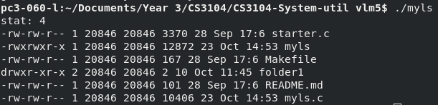
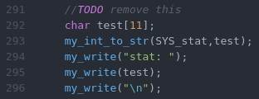
Figure 3: A comparison of the output of mylist and the output of ls -n within the same directory.
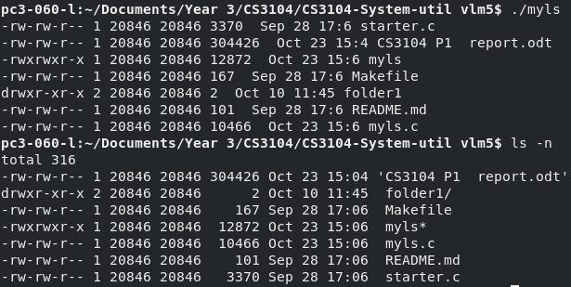

Figure 4: An example of error handling when a system call fails.
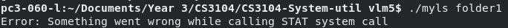
Figure 5: An example of program functionality when accessing sub-directories.
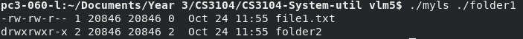
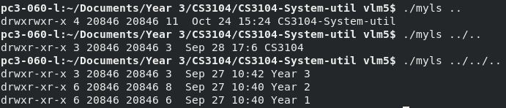
Figure 6: An example of program functionality when accessing parent directories.
Figure 7: An example of program functionality when accessing non-existent files.
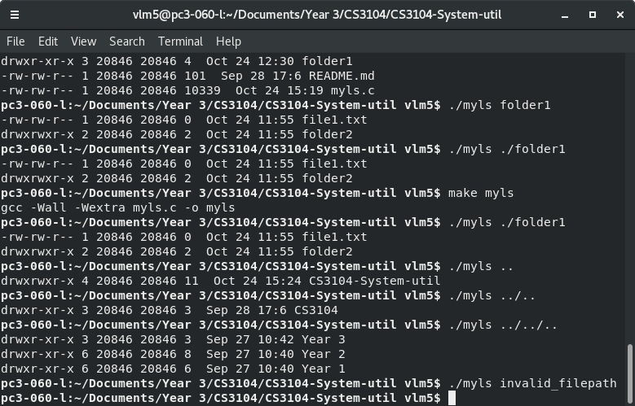

Difficulties & Conclusion
The design of this practical was rather difficult, as I realised how much I’ve been relying on library functions and memory allocation so far (e.g. I initially wanted to put all file details in a linked list and implement pretty printing, which would have been easy with basic library functions, but having limited tools lead to a completely different design). I spent far more time contemplating on design decisions than writing code, which was a good choice in retrospect, as I could identify the source of errors very easily.
I also had to rely on code taken from the internet for a significant part of the practical, interpret that code to make sure it does what is needed of it, and modify it as needed. I was very concerned with accidentally plagiarising someone or not taking credit for sections I’ve written and changed, so keeping track of my references was an important focus during this practical.
I believe I’ve written a stable and complete solution to the basic requirements, although I did not have the time to attempt extensions. Given more time, I would have liked to implement more of the string library and re-implement my_write() as a variadic function: so that it concatenates any number of strings internally and prints them all out as one string. I also would have liked to implement other Unix commands with the use of Inline Assembly.

References
[1] Manual getdents: http://man7.org/linux/man-pages/man2/getdents.2.html
[2] Manual stat: http://man7.org/linux/man-pages/man2/stat.2.html
[3] Printing file permissions: https://stackoverflow.com/questions/10323060/printing-file-permissions-like-ls-l-using-stat2-in-c
[4] How to convert int to char in C? : https://stackoverflow.com/questions/2279379/how-to-convert-integer-to-char-in-c
[5] What is mode_t in C?: https://jameshfisher.com/2017/02/24/what-is-mode_t.html
[6] strcat implementation: https://stackoverflow.com/questions/2488563/strcat-implementation
[7] The starter code provided in starter.c

